M.L.E. Enterprises is looking for 10 married couples to be featured in the marriage collaboration book, “And the Two Shall Become One: The Art of Sacrifice”!

Why be in a collaboration book?
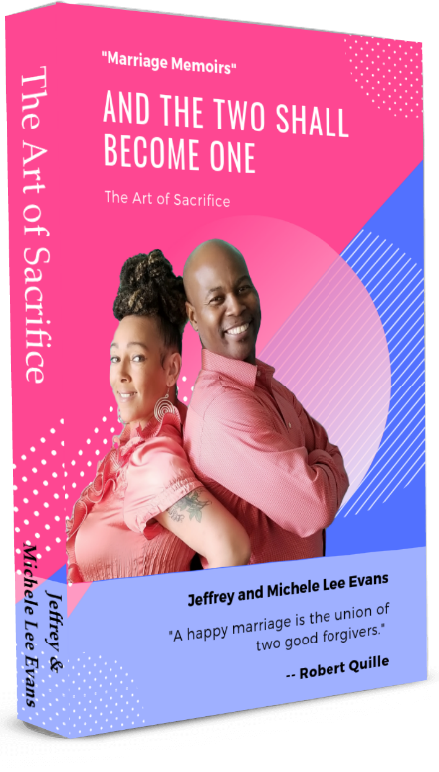
- People love to read a variety of stories from different people, with different outlooks, challenges and levels of success.
- You will now have 20 other people marketing a book that YOU and your spouse are featured in, increasing your visibility.
- You will be able to network with your co-authors to leverage your book and make it profitable.

This marriage collaboration book has the purpose of guiding those contemplating marriage on how to approach those uncertain times, and helping other married couples strengthen their union by sharing our struggles, communication technics and the successes we have achieved in order to remain a cohesive unit.

Author Investment

One-time payment of $367
Or
- Deposit of $67.00
- Monthly payment of $100 for three months.

You will receive:
- Access to the Marriage Book Group on Facebook for easy access to needed docs
- NO WRITING NECESSARY! Phone interview questions will be transcribed for each couple.
- Editing and publishing of transcribed documents
- Book website with author dedicated pages ($997 value)
- Pre-sale capture page and flyer
- Book cover design with your names on front and photos on back covers ($97 value)
- 10 free copies of the book ($50 value)
- Opportunities for radio and television interviews, speaking engagements
- Assistance with book launch events

***You don’t need a book in your hand to make money. Pre-sale your book before it’s printed to help with the cost of the investment payments! Pre-sale goal of 20 books at $20 per book pays for more than HALF of your investment cost***

